**Question 1:**

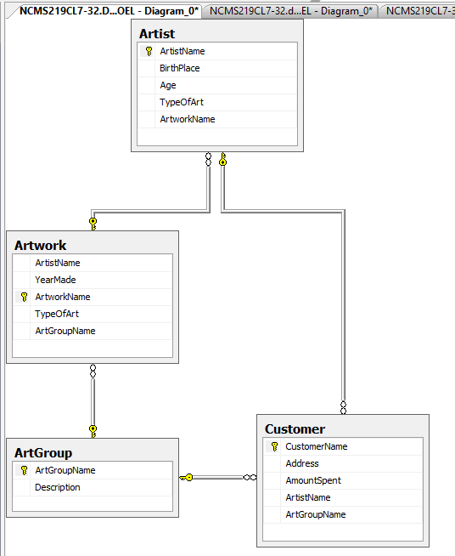

**Question 2:**

create database DBMS_OEL

use DBMS_OEL

create table ArtGroup(

ArtGroupName nvarchar(25) primary key,

[Description] text not null

)

create table Artwork(

ArtistName nvarchar(15) not null,

YearMade int not null,

ArtworkName nvarchar(15) primary key,

TypeOfArt nvarchar(20) not null,

ArtGroupName nvarchar(25) not null,

foreign key (ArtGroupName) references ArtGroup(ArtGroupName)

)

create table Artist(

ArtistName nvarchar(15) primary key,

BirthPlace int not null,

Age int not null,

TypeOfArt nvarchar(20) not null,

ArtworkName nvarchar(15) not null,

foreign key (ArtworkName) references Artwork(ArtworkName)

)

create table Customer(

CustomerName nvarchar(15) primary key,

[Address] text not null,

AmountSpent int not null,

ArtistName nvarchar(15) not null,

ArtGroupName nvarchar(25) not null,

foreign key (ArtistName) references Artist(ArtistName),

foreign key (ArtGroupName) references ArtGroup(ArtGroupName)

);

**Question 3:**

**ArtGroup**

insert into artgroup values ('Portraits', 'xyz', 1)

insert into artgroup values ('Still lifes', 'xyz', 2)

insert into artgroup values ('Works by Picasso', 'xyz', 3)

insert into artgroup values ('Works of the 19th century', 'xyz', 4)

insert into artgroup values ('Portraits', 'xyz', 5)

insert into artgroup values ('Still lifes', 'xyz', 6)

insert into artgroup values ('Works by Picasso', 'xyz', 7)

insert into artgroup values ('Works of the 19th century', 'xyz', 8)

insert into artgroup values ('Portraits', 'xyz', 9)

insert into artgroup values ('Still lifes', 'xyz', 10)

**Artwork**

insert into artwork values ('Mahwish', 1996, 'Unconceptual', 'Painting', 'Portraits')

insert into artwork values ('Ali', 2000, 'Black Letters', 'Lithography', 'Still lifes')

insert into artwork values ('Kashif', 2005, 'List', 'Sculpture', 'Works by Picasso')

insert into artwork values ('Ahsan', 2004, 'Flat Shadow', 'Photograph', 'Works of the 19th cen')

insert into artwork values ('Munir', 2008, 'Try Harder', 'Sculpture', 'Portraits')

insert into artwork values ('Shahwaiz', 2014, 'Roadkill', 'Photograph', 'Still lifes')

insert into artwork values ('Hamza', 2015, 'Another Show', 'Lithography', 'Works by Picasso')

insert into artwork values ('Faizan', 2007, 'Holes in the wall', 'Sculpture', 'Works of the 19th cen')

insert into artwork values ('Yousuf', 2010, 'Awful things', 'Photograph', 'Portraits')

insert into artwork values ('Faiz', 2011, 'No Negative', 'Painting', 'Still lifes')

**Customer**

insert into artist values ('Mahwish', 'Karachi', 40, 'Painting', 'Unconceptual', 'Baroque')

insert into artist values ('Ali', 'Lahore', 35, 'Lithography', 'Black Letters', 'Rococo')

insert into artist values ('Kashif', 'Islamabad', 36, 'Sculpture', 'List', 'Neoclassical')

insert into artist values ('Ahsan', 'Peshawar', 37, 'Photograph', 'Flat Shadow', 'Romanticisim')

insert into artist values ('Munir', 'Multan', 38, 'Sculpture', 'Try Harder', 'Realism')

insert into artist values ('Shahwaiz', 'Hyderabad', 45, 'Photograph', 'Roadkill', 'Impressionism')

insert into artist values ('Hamza', 'Rawalpindi', 60, 'Lithography','Another Show', 'Post Impressionism')

insert into artist values ('Faizan', 'Faislabad', 38, 'Sculpture','Holes in the wall', 'Fauvism')

insert into artist values ('Yousuf', 'Quetta', 47, 'Photograph','Awful things', 'Expressionis')

insert into artist values ('Faiz', 'Murree', 50, 'Painting','No Negative', 'Cubsim')

**Question 4:**

**a)**

select * from artist where artistname like '%sh%' not like '[0-9]%' and birthplace = 'Karachi';

**b)**

select top 5 customername, artgroupname from customer order by amountspent;

**c)**

select artgroupname, count(artgroupname) from customer group by count(artgroupname) order by count(artgroupname) desc;

**d)**

select artwokname, artistname from artist having min(price);

**e)**

select artist, artworkname, yearmade from artist inner join artwork on artist.artworkname = artwork.artworkname;